Implementing Web Application

Create IBM DB2 And Connect With Python

(Customer Care Registry_PNT2022TMID52279)

Step 1:login with ibm.com ,search with DB2 in search catalog

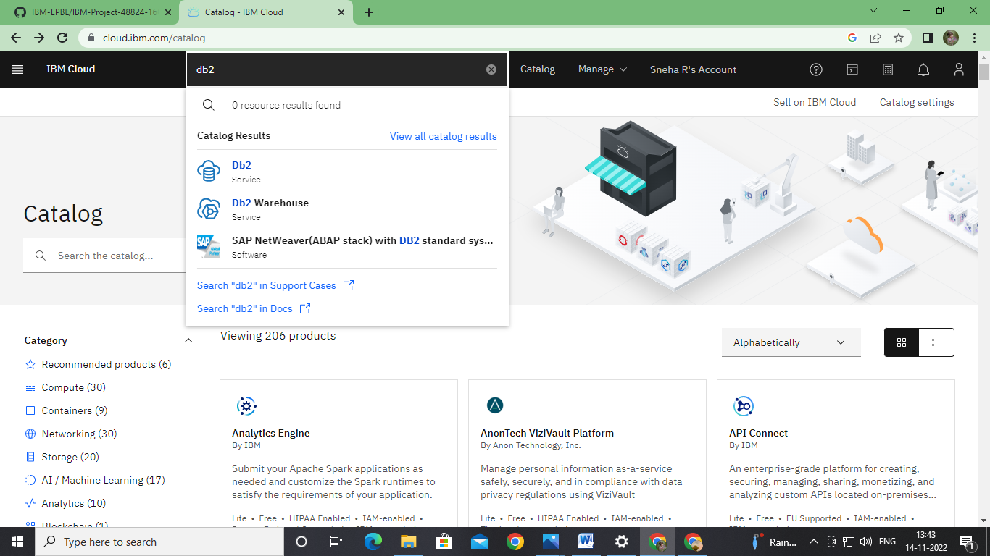

Step2: Connect with python code to db2 using import ibm_db command:

